**UNIVERSITI TUNKU ABDUL RAHMAN**

**UCCD2323**

**Front End Web Development**

**Group Name: Lucas**

|  |  |  |  |  |  |
| --- | --- | --- | --- | --- | --- |
| **Member** | **Name** | **ID** | **Course Code** | **Programme** | **Practical Group** |
| **1** | Pang Chin Wei  (Leader) | 20ACB01232 | UCCD2323 | CS | P16 |
| **2** | Tham Ying Han | 20ACB01170 | UCCD2323 | CS | P16 |
| **3** | Toh Yan Xian | 19ACB03356 | UCCD2323 | CS | P16 |
| **4** | Lee Jian Zhen | 19ACB02281 | UCCD2323 | CS | P16 |

**Website URL:** [**https://lucastuition.azurewebsites.net/**](https://lucastuition.azurewebsites.net/)

**Main Page: https://lucastuition.azurewebsites.net/index.html**

# **Marking Scheme**

|  |  |  |  |  |  |
| --- | --- | --- | --- | --- | --- |
|  | | **1** | **2** | **3** | **4** |
| ID | | **20ACB01232** | **20ACB01170** | **19ACB03356** | **19ACB02281** |
| Name | | **Pang Chin Wei** | **Tham Ying Han** | **Toh Yan Xian** | **Lee Jian Zhen** |
| Degree Programme | | **CS** | **CS** | **CS** | **CS** |
| Course Code | | **UCCD2323** | **UCCD2323** | **UCCD2323** | **UCCD2323** |
| Practical Group | | **P16** | **P16** | **P16** | **P16** |
| Website Title | | **Lucas’s Tuition** | | | |
| Website URL | | **https://lucastuition.azurewebsites.net/** | | | |
| Main Page (eg. Index.html) | | **index.html** | | | |
| Overall report quality [G] | (Scale x 1) 5% |  |  |  |  |
| Introduction [G] | (Scale x 1)  5% |  |  |  |  |
| Literature Review [G] | (Scale x 2)  10% |  |  |  |  |
| Design [G] | (Scale x 2)  10% |  |  |  |  |
| Evaluation [G] | (Scale x 2)  10% |  |  |  |  |
| References [G] | (Scale x 1)  5% |  |  |  |  |
| Clarity of voice [I] | (Scale x 1)  5% |  |  |  |  |
| Flow of presentation [I] | (Scale x 1)  5% |  |  |  |  |
| Use of cookies, local storage, session storage [I] | (Scale x 3)  15% |  |  |  |  |
| Availability during offline and web notifications [I] | (Scale x 3)  15% |  |  |  |  |
| Overall web site functionalities [G] | (Scale x 1)  5% |  |  |  |  |
| Overall layout and appearance [G] | (Scale x 2)  10% |  |  |  |  |
| Total (100%) | |  |  |  |  |

|  |  |
| --- | --- |
| **Scale (0-5)** | **Description** |
| 5 | Excellent work produced. Evidence of in-depth study **and** critical thought |
| 4 | Good work produced. Evidence of in-depth study **or** critical thought |
| 3 | Average work produced. Evidence of some study **or** thought, although not extensively covered |
| 2 | Below average work produced **or** work **not** supported by any study/basis |
| 1 | Poor work performance **or** work **not** supported by any study/basis |
| 0 | Not attempted |

**Marking Rubric**

Table Of Contents

|  |  |
| --- | --- |
| **Content** | **Page No** |
| Introduction | 4 |
| Literature Review | 5~13 |
| Design | 14~20 |
| Evaluation | 21-30 |
| References | 31 |

Chapter 1: Introduction

The website we chose for this assignment is a website for a Tuition Centre. We chose this because out of the other topics, Tuition Centre was the only one we were familiar with.

In the past, most of the tuition centres in Malaysia don’t really have a website. They mostly only have a Facebook page to post important updates and events. Recently, there were some tuition centres in Malaysia who created their own website like https://catalyst.edu.my/ which is a website for Catalyst Education Sdn Bhd. Creating a website for a Tuition Centre is a very good idea because important updates and events can be shared easily through the website.

The audience for the tuition centre website is basically students and their parents. Students can get the timetable of their chosen course and register through this website. As for the parent’s side, they can get some general information of the tuition centre and get recent updates from the tuition centre. Furthermore, they can also leave questions about their website. . Besides that, admin of the tuition centre is also one of the target audience of the website. Admins can read new messages and registrations through the website easily.

Before website for tuition centres were made, people usually had to go to the nearest branch of the tuition centre to get information of it. The quickest way to get information is through a phone call, which is also not very convenient. Therefore, with the help of a website, information of the tuition centre can be accessed by anyone with internet connection. In the other hand, for a student to register or ask question about the tuition centre, they had to go to the branch. With a website, they can just key in their details in the website and finish the registration.

The website can benefit its user by giving a platform for the user to connect with the tuition centre. Besides that, users can also get important information and updates easier from the website. This not only can benefit the tuition centre, but it can also benefit their audience. Furthermore, admin from the tuition centre can also login to the admin page and read new registrations and new messages easily through this page.

Chapter 2: Literature Review

**System 1- Catalyst EDU**

One of the existing systems for tuition centre is www.catalyst.edu.my. The biggest advantage of this existing system is that it is bilingual as it has both English and Chinese text, as shown in Figure 1. This system also allows the user to switch languages. This allows them to increase their target audience further to Chinese who are unable to read English. Another advantage of this system is that it provides online tests for students, as shown in Figure 2. This allows students and their parents to know the capabilities of themselves and whether they are ready for the major tests such as SPM, UEC and STPM. Besides, this system implemented a top-of-page button that allows the user to jump to the top of the page by clicking it. As shown in Figure 3, the user can click the arrow button to go back to the top of the page. This results in a good user experience due to the convenience when browsing through the website provided by this button.

One disadvantage of this existing system is that it does not show the day and time of their classes. This causes confusion among users who want to register for class but do not know when the class is conducted. Another disadvantage of this system is that its navigation bar fonts are very small. As we can see in Figure 4, the text of the navigation bar is rather small, especially when compared to other websites. This may influence the user experience negatively especially due to the targeted audience of the website being parents who are mostly middle-aged and may have trouble reading small words. This may result in less parents choosing this tuition centre due to them unable to read the text clearly and unable to decide whether the tuition centre is worthy.

One limitation of this system is that it lacks a shop feature that sells notes and reference books. This results in difficulties for the tuition centre in making their teachings more accessible for more users. One recommendation for the system is that it implements a timetable feature so that users are able to know the timeslot of the classes and improve the user experience. This results in convenience among users when browsing the website and parents and students more likely to choose this tuition centre.

**System 2 – AI Tuition Centre**

Another existing system for tuition centre is https://aituition.com. One of the advantages of this system is that it provides a schedule list of their classes for the user. In Figure 5, it shows that this website provides the users a list of available classes and listing down the day and time of the classes. This allows the user to be able to know what is the time of their classes when registering and results in a better user experience. Furthermore, this system has a dedicated page for announcements, as in Figure 6. This allows the user to be able to get important information easily without needing to worry about other less important information getting in their way.

One of the disadvantages of this system is that no text is shown when the user mouse hovers above the cart and search icon. Some users may be confused by the functions of these buttons as no descriptions were given to the buttons. Another disadvantage of the system is that the buttons that redirects the user to important websites such as admission and student portal are located in the middle of the About Us page. As we can see in Figure 7, the scrollbar shows that the links to important websites are at the middle of the page. This results in a bad user experience as new users will be confused in how to access the aforementioned important websites.

One limitation of this system is that it does not have a separate navigation bar for important websites such as admission and student portal that is easy to access, such as at the top of the page. This limitation will result in a negative user experience overall due to the confusion caused and possibility of users missing out on important information. A recommendation for this system is that it adds the navigation bar for important websites as mentioned above. Another recommendation for this system is that it adds short description for the cart and search icon so that less people are confused about their function.

**System 3 - VBest**

The third existing system for tuition centre is https://www.vbest.edu.my. The first advantage of the system is that its programs are sorted neatly in a single element of the navigation bar. As shown in Figure 8, all programs for different levels of education are sorted in the Programs element of the navigation bar. This allows the user to access the program appropriate to them easily and results in a good user experience. Another advantage of this system is that they provide online assessments to students. In Figure 9, it shows that the website provides tests for different levels of education. This allows students to take the assessment and know their capabilities easily. Students will then be clearer whether they are ready for the major exams like SPM and STPM and convince themselves to join the tuition classes more easily if they feel like they are not ready. The third advantage of the system is that it has a rating feature that allows the user to rate the tuition centre. Parents and students can write down their ratings and comments on the tuition centre and post them to the website, as shown in Figure 10. This allows users to be able to judge whether the tuition centre is worth a try more easily.

The first disadvantage of this system is that many pages of this system consist of long paragraphs of descriptions with hard-to-read texts that bores the user. In Figure 11, it shows that the website contains long, tedious paragraphs that are time consuming to read through with very little importance. Users will feel impatient and annoyed when they see a large amount of text with small font size and thus not reading the text thoroughly, even when the paragraphs may contain important information and announcements. This results in a bad user experience for the users. Another disadvantage of the system is that it does not show the day and time of the classes. Referring to Figure 11 once again, the website does not state the day and time when their classes will be conducted even though this paragraph is in the programs website of the system. As mentioned, when discussing about the first existing system, users will be confused when they try to register for a class but are unable to know what day and time their classes will be conducted.

One limitation of this system is that the user is unable to register for class in the website. This results in the user feeling confused when trying to register for classes after reading the description of their courses. One recommendation for this system is that it implements a timetable feature that lists the day and time of classes. As mentioned in the first existing system, this improves the user experience as they are able to know what the time of the classes is.

**How our website would be better**

One advantage our system has over other existing systems is that our system has a timetable function that lists all available courses neatly in a table. As shown above, many tuition systems do not have this feature, and this impacts the user experience severely. Our system separates different courses with different background colour that are vibrant and distinct from each other on the table so that users can tell what the day and time of the class of a subject is easily, as shown in Figure 12. Moreover, a list of available subjects can be found under the timetable that shows the day and time of a class which results in less confusion. Another different thing our system has over existing systems is that it shows the most popular classes among students, as we can see in Figure 13. This results in users feeling they need to register for the popular class quickly or the number of vacancies will be over quickly. This psychological effect results in more students registering for our tuition due to the aforementioned psychological effect.

Images:

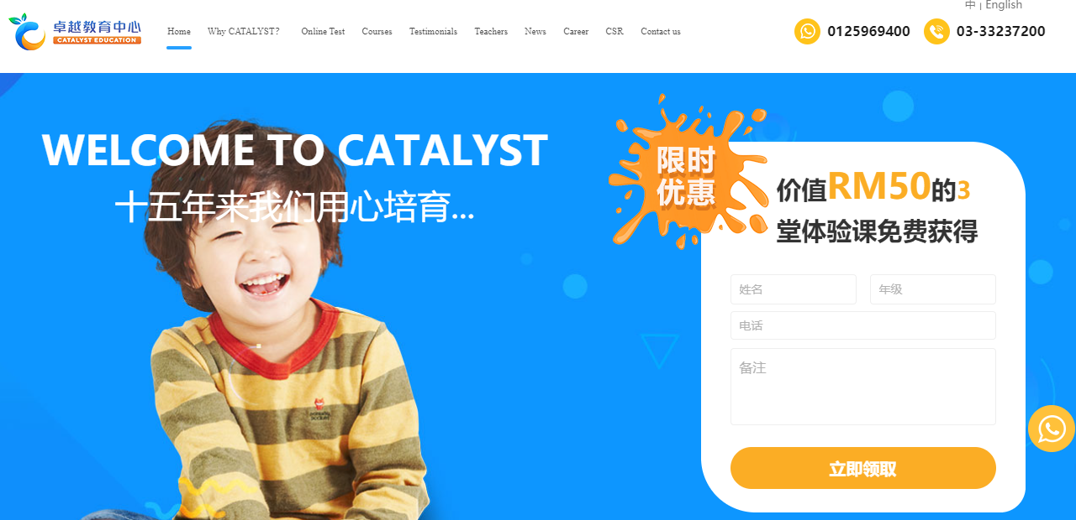

Figure 1: Bilingual feature of www.catalyst.edu.my/

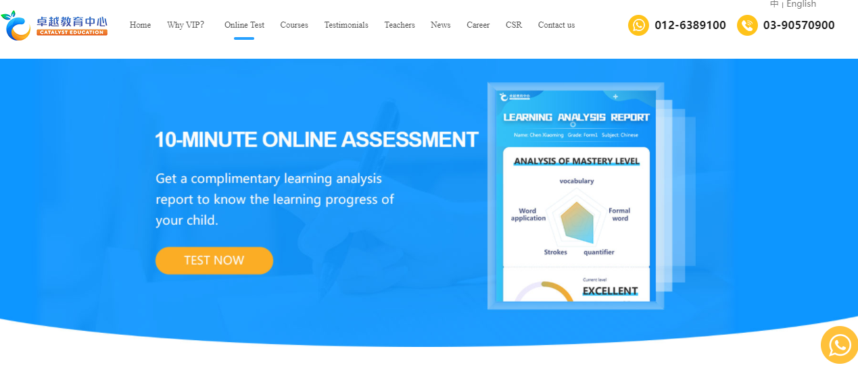

Figure 2: Online test feature of www.catalyst.edu.my/



Figure 3: Back to Top Page feature of www.catalyst.edu.my/



Figure 4: Small navigation bar text of www.catalyst.edu.my/

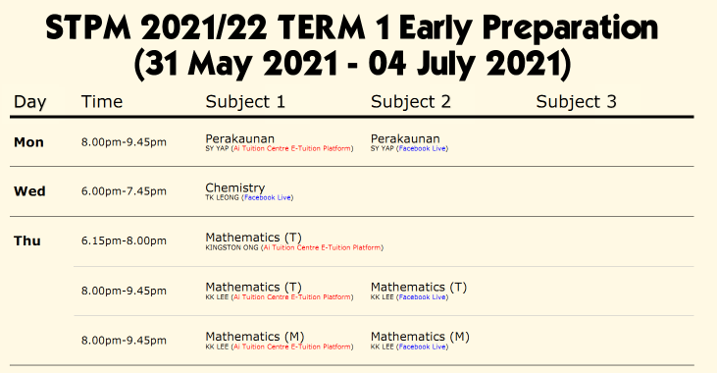

Figure 5: Schedule list of classes of https://aituition.com

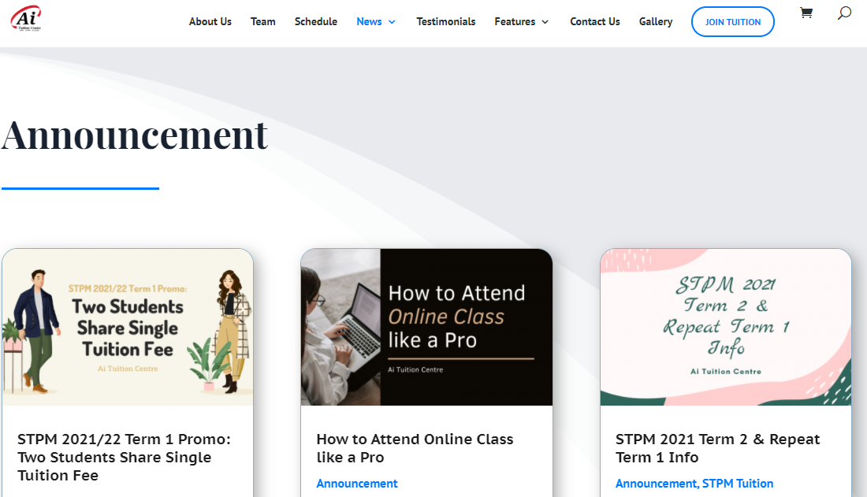

Figure 6: Announcement page of https://aituition.com

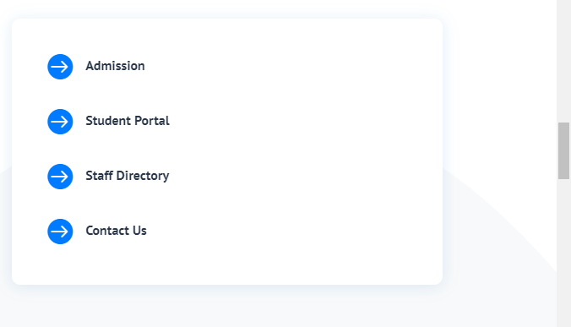

Figure 7: Important links of https://aituition.com located in the middle of the About Us page

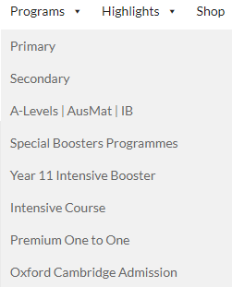

Figure 8: Programs of https://www.vbest.edu.my being sorted neatly in a single element of navigation bar

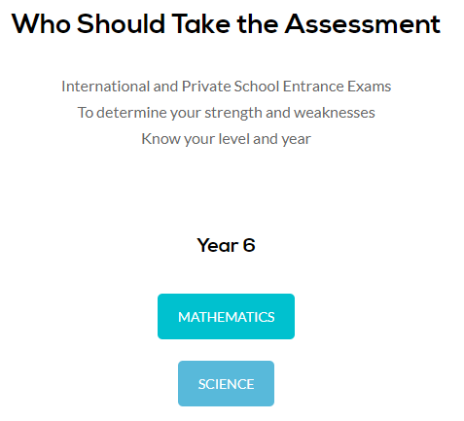

Figure 9: Online assessments of https://www.vbest.edu.my

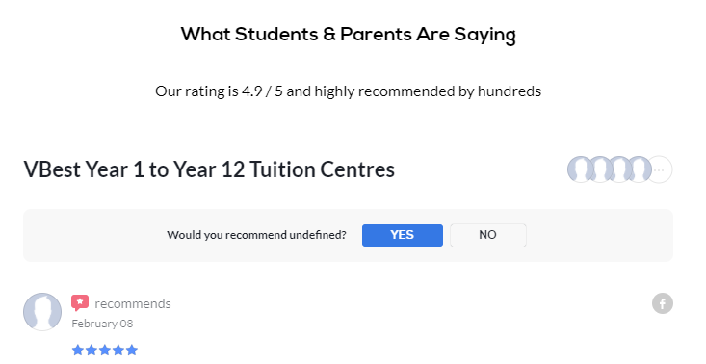

Figure 10: Rating feature of https://www.vbest.edu.my

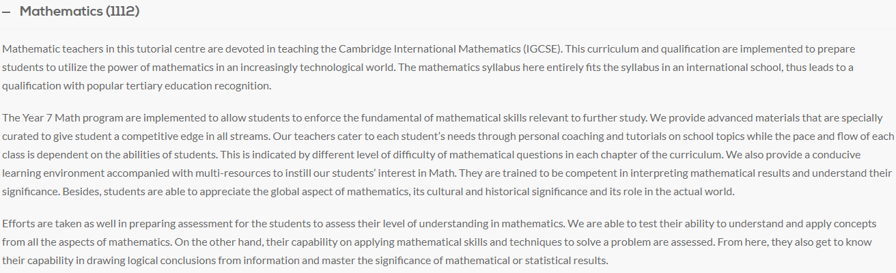

Figure 11: https://www.vbest.edu.my not showing the day and time of their classes and having long, unnecessary text.

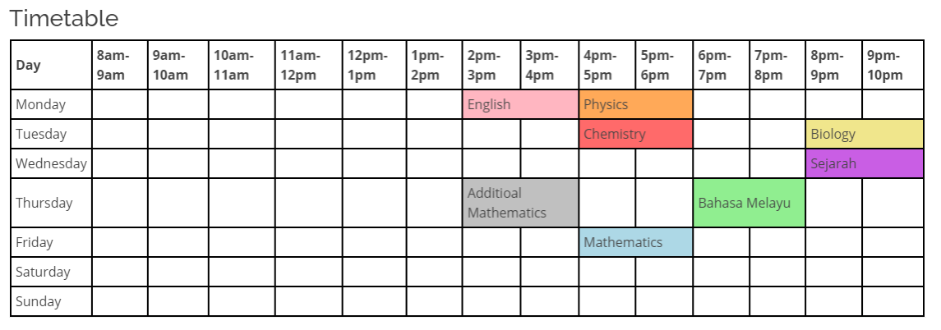

Figure 12: Timetable feature of our system

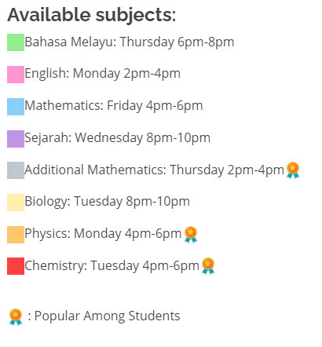

Figure 13: Our system showing popular classes among students

Chapter 3: Design

Wireframe

**Index**

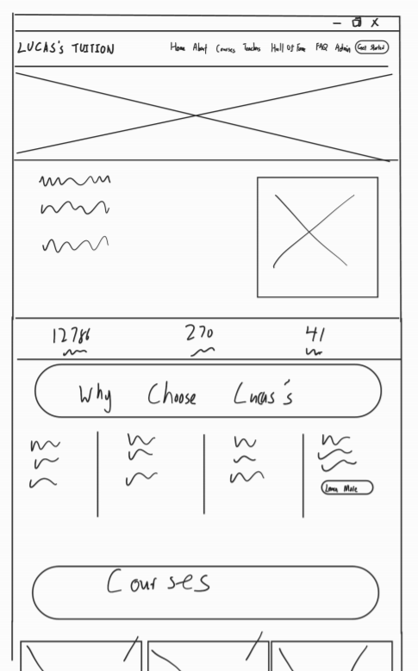 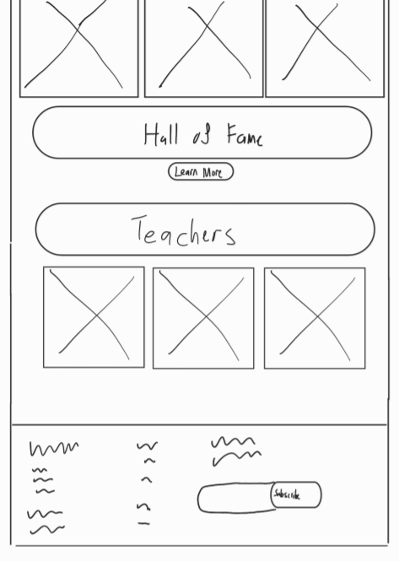

**About Us**

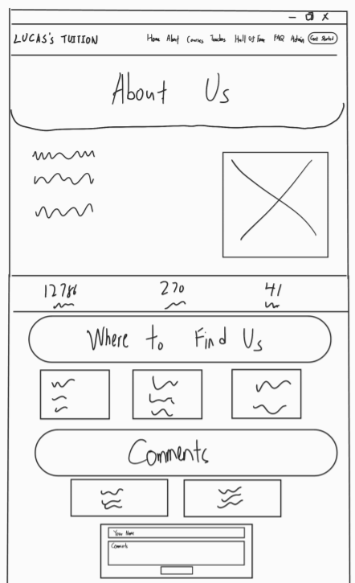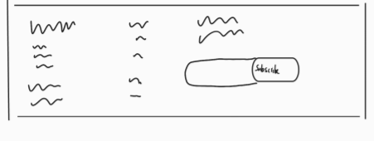

**Courses**

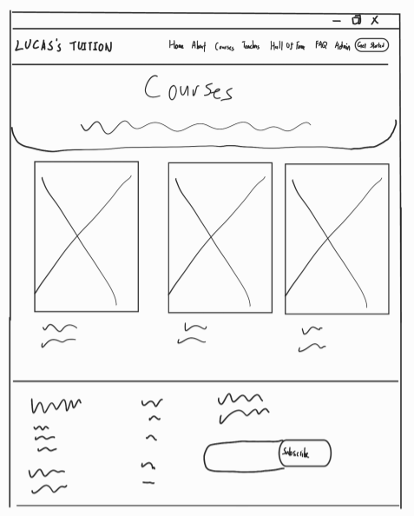

**Courses-details-xxx (*xxx stands for SPM, STPM and UEC)**

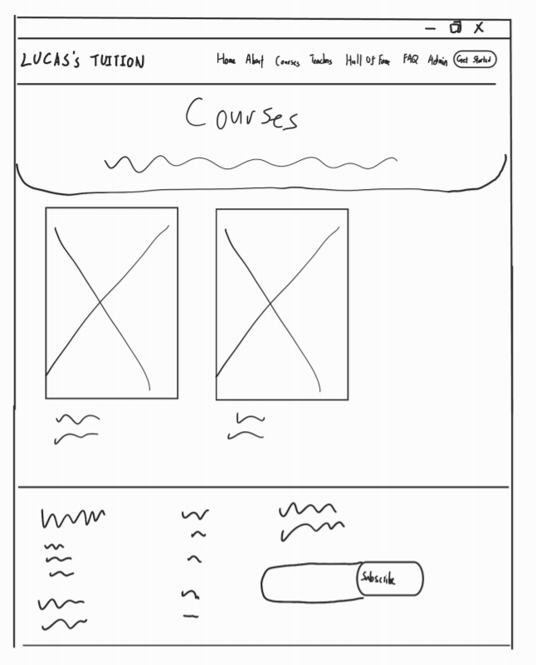

**Courses-details-xxx-yyy**

**(*xxx stands for SPM, STPM and UEC,*yyy stands for Science and Commerce)**

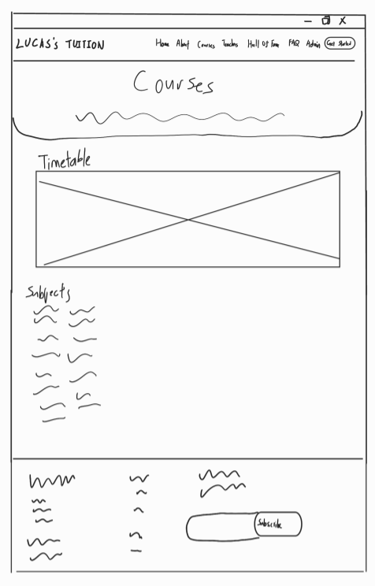

**Trainers**

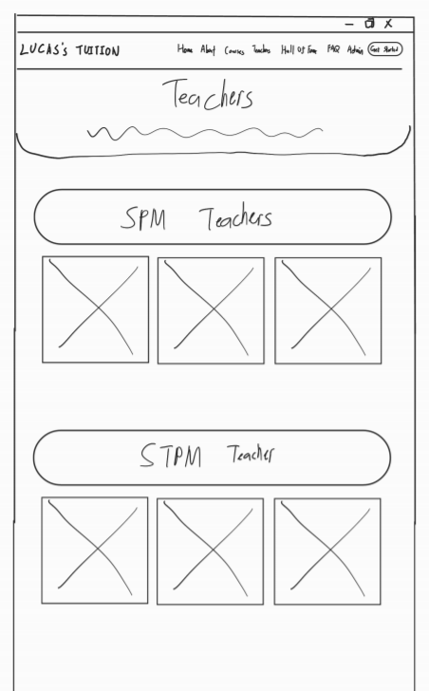 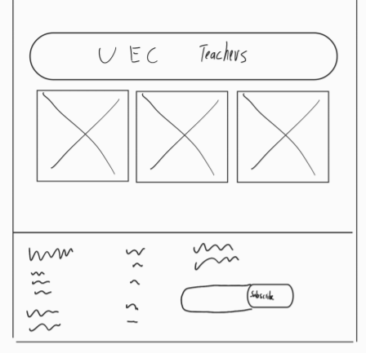

**Hall Of Fame**

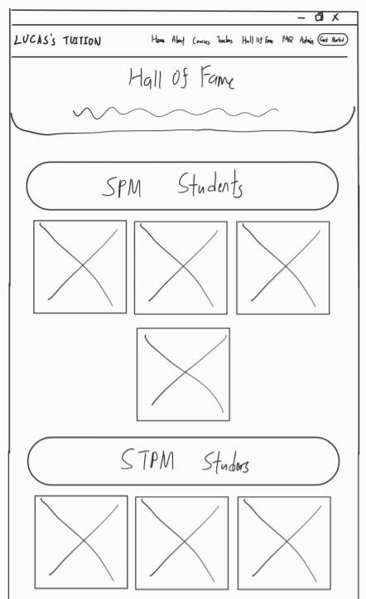 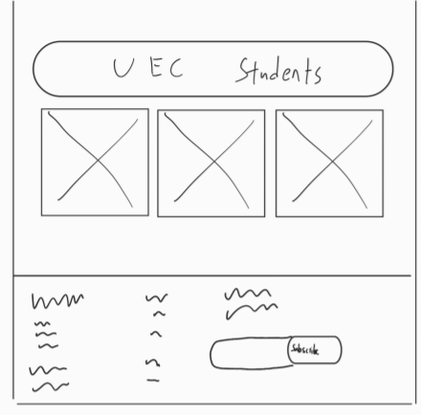

**FAQ**

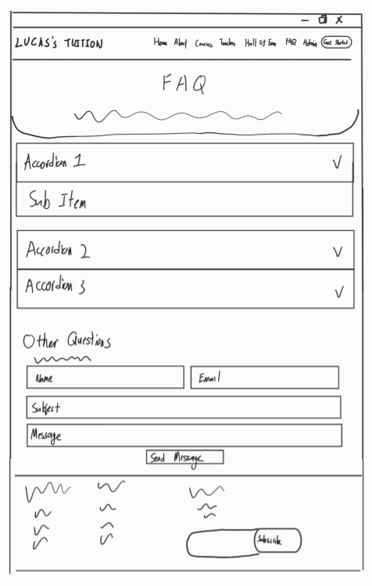

**Admin Login**

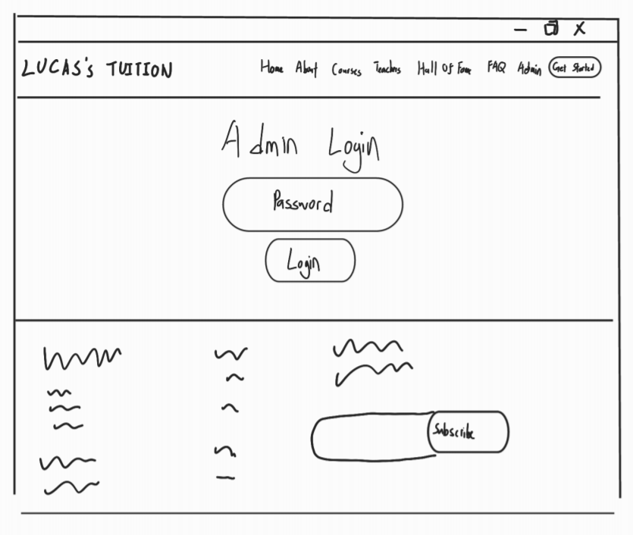

**Admin**

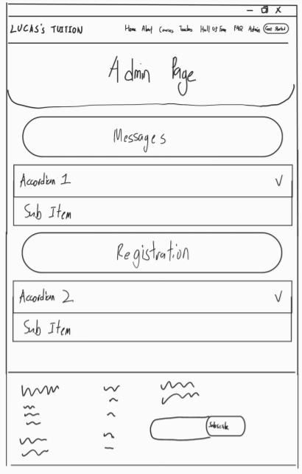

**Register**

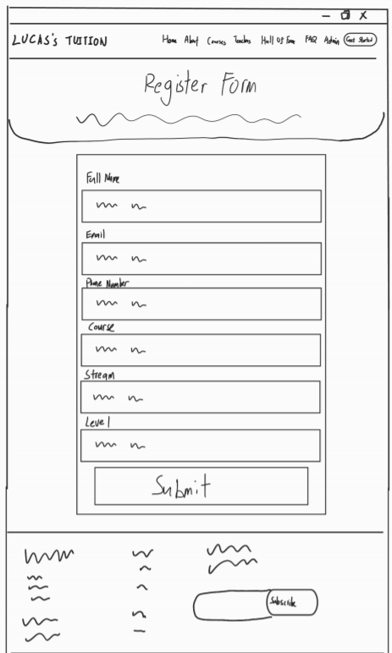

Site Map

**Chapter 4: User Manual**

**Main page**

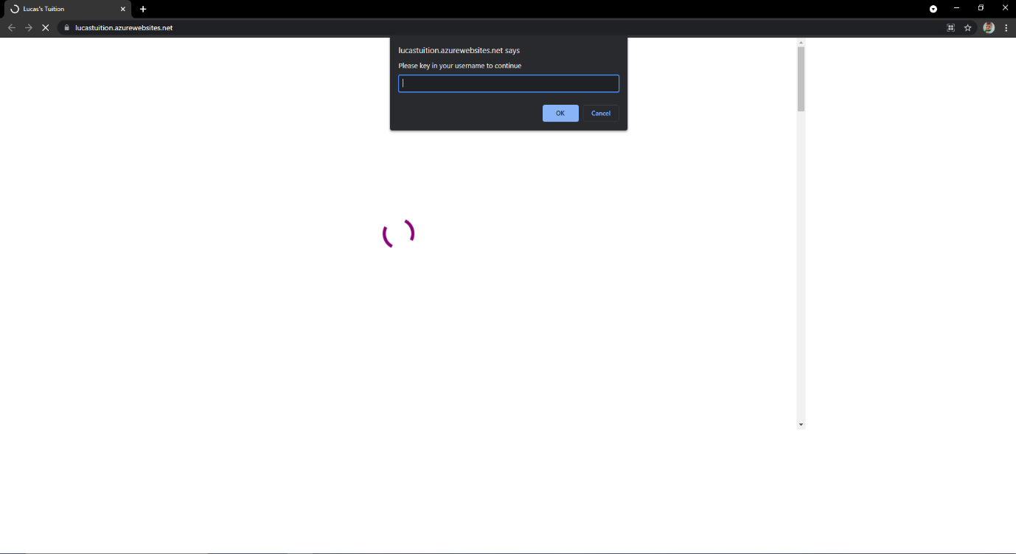

The website will request username before entering our website.

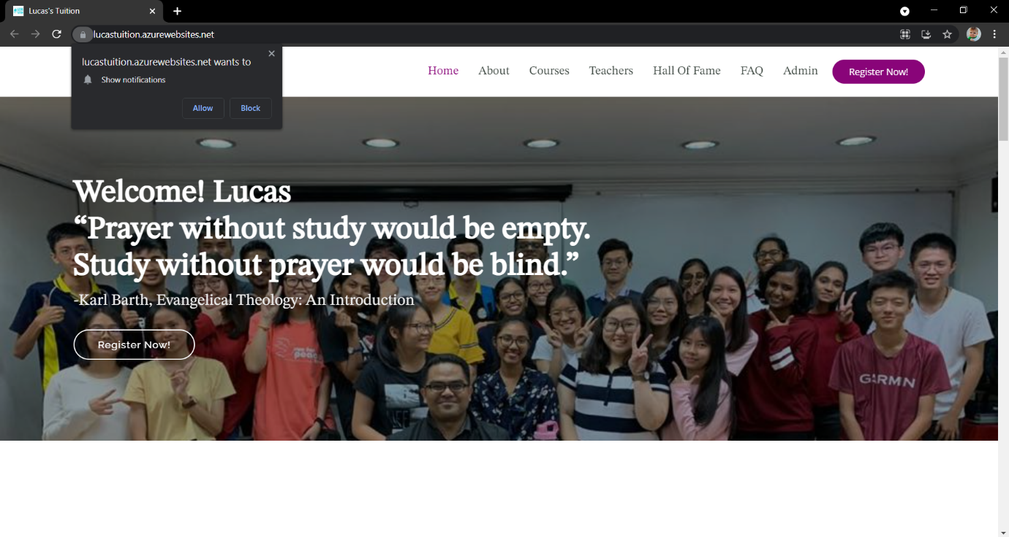



Main page of our website, in this page contain navigation bar which will link user to another page. If user scroll down, it will appear some information about our tuition such as courses, teachers, hall of fame, etc.

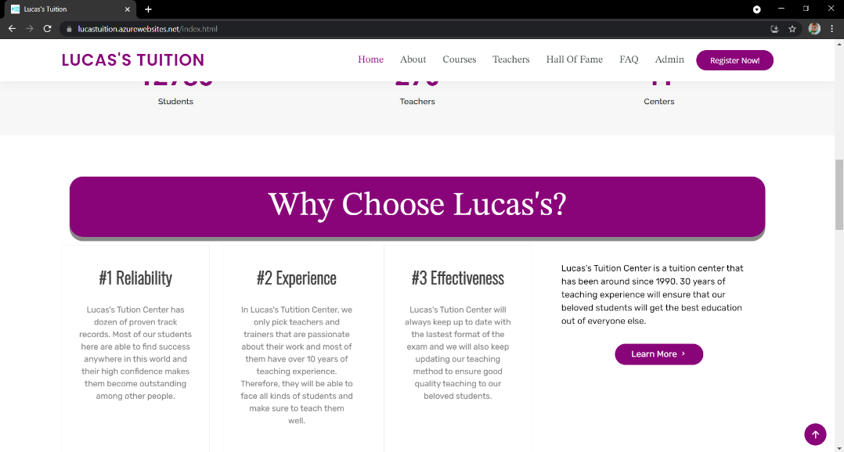

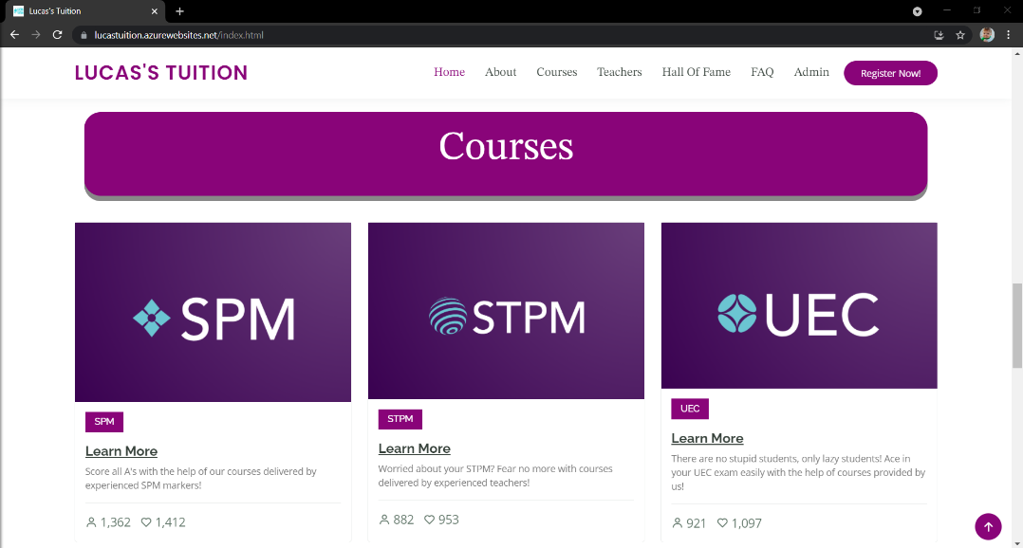

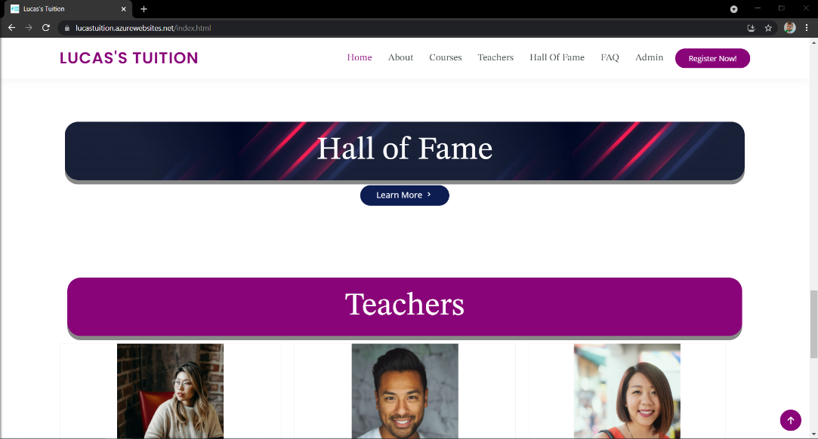

User can click the up-arrow button to direct to the top of page.

**About page**

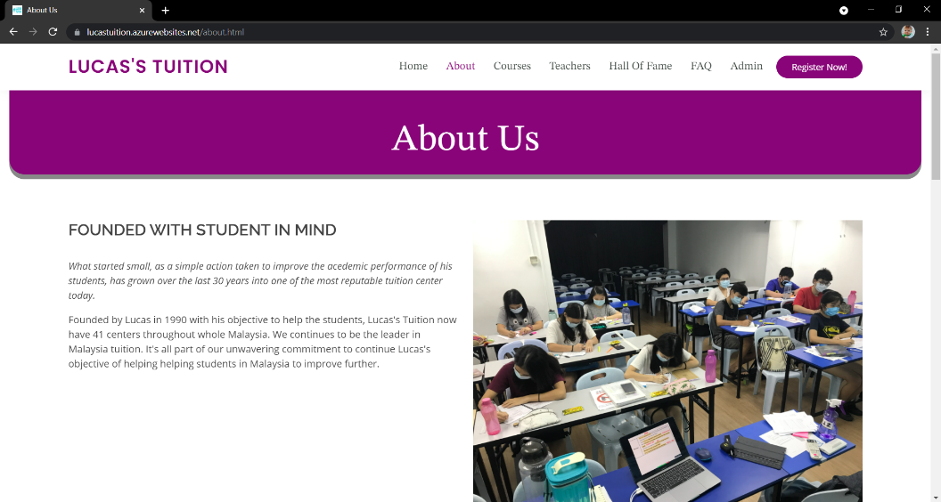

In about page, user can learn about our tuition. User can also know more about our tuition such as location and comments if they scroll down as shown below.

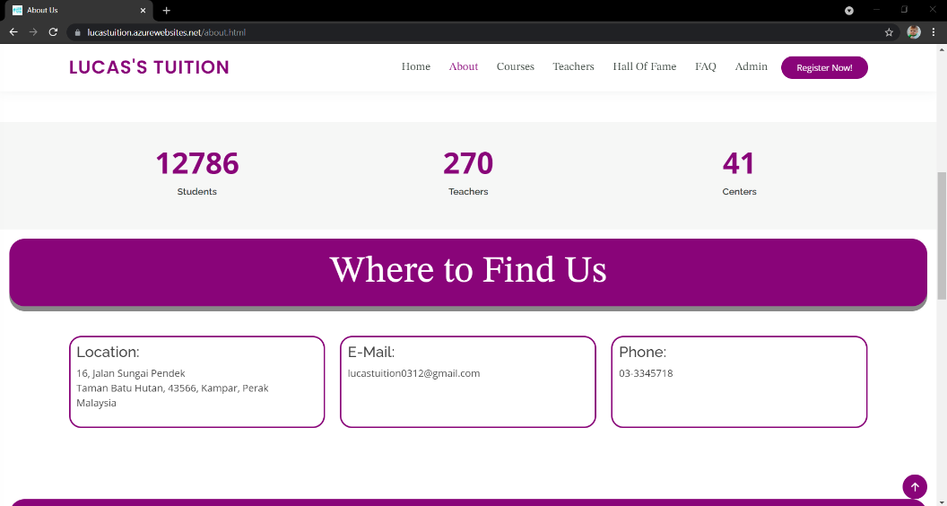

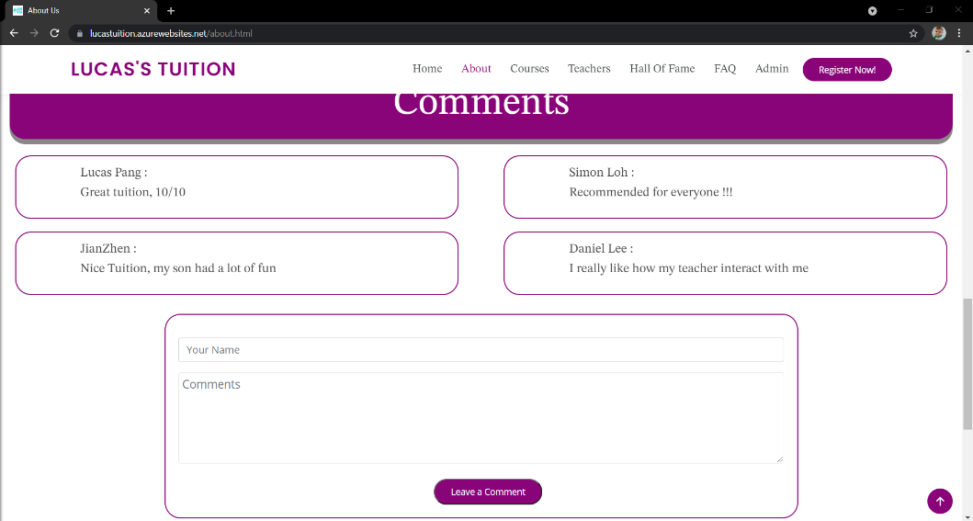

**Courses page**

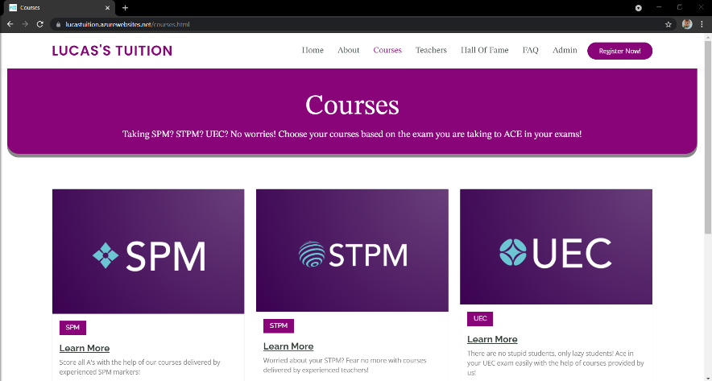

Our tuition provides 3 level for student to choose which is SPM, STPM, and UEC. User may click Learn More to choose which stream they wanted to study. After student click on a stream, it will show the timetable for the course.

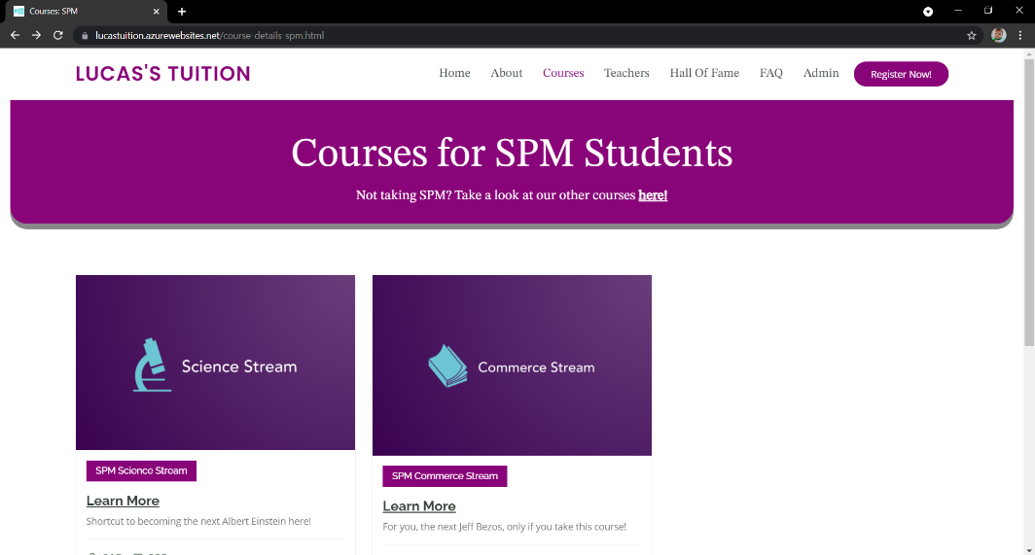

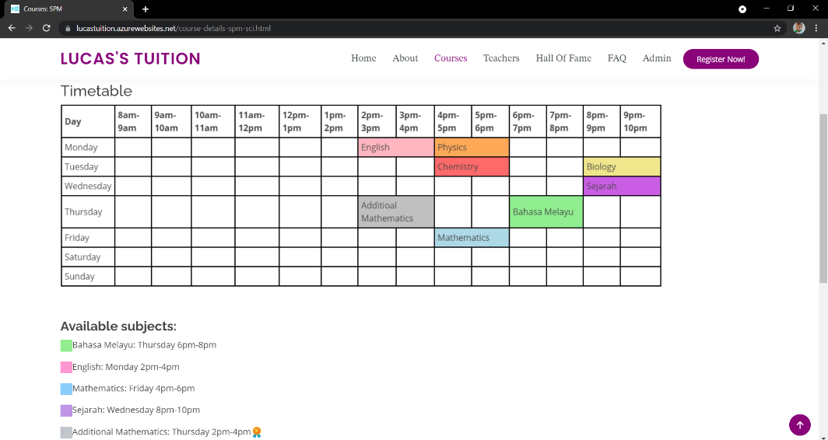

**Teachers page**

This page will let user to know more about our teacher.

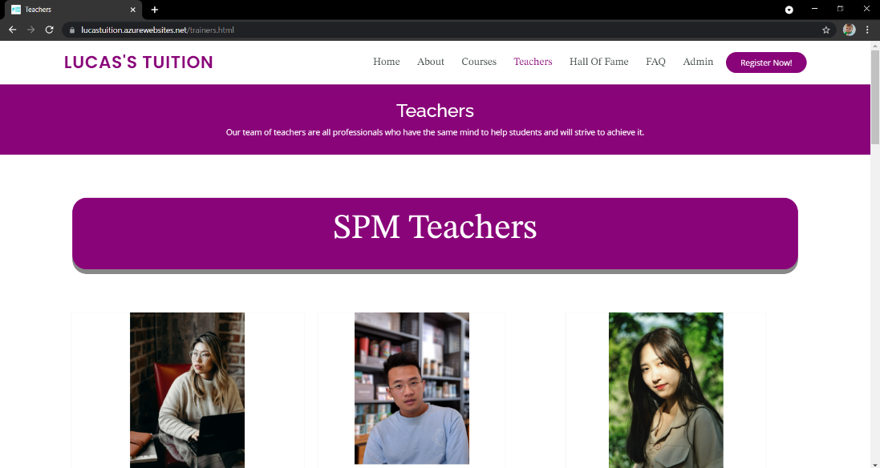

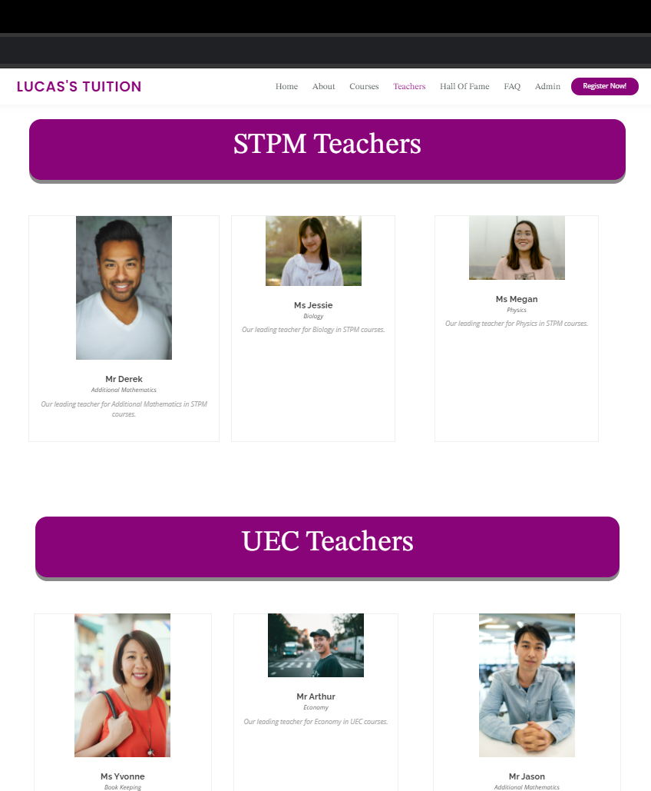

**Hall of Fame page**

Hall of Fame page will show our honorable students.

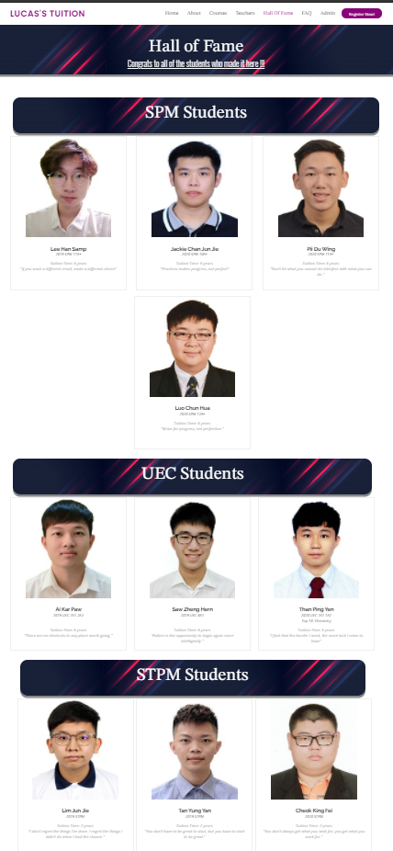

FAQ page

User can seek or ask question at this page.

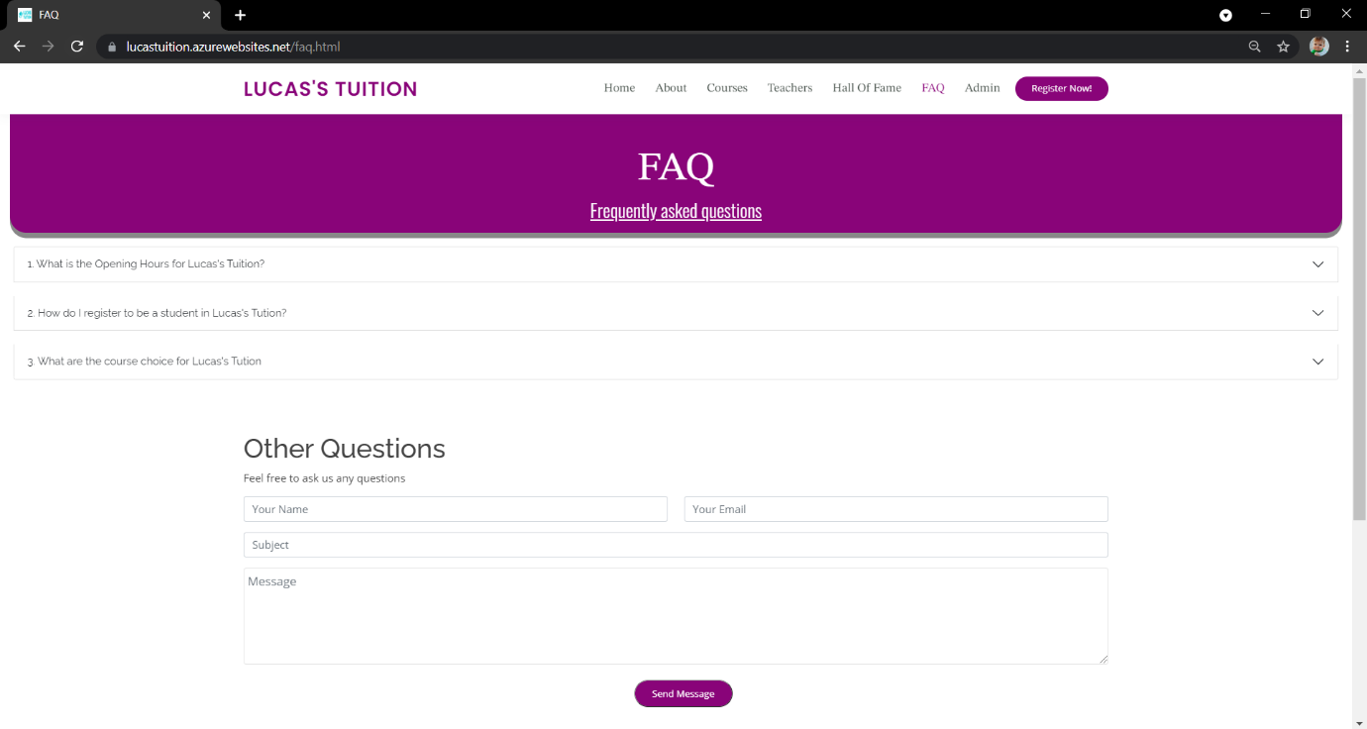

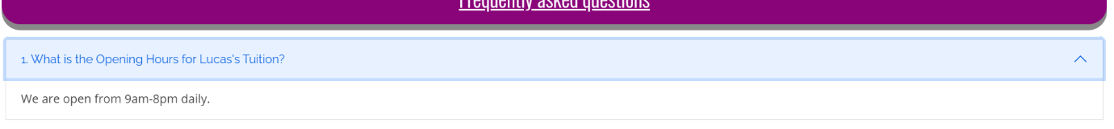

If user send a message to the website successfully, it will send a notification to the user.



**Admin page**

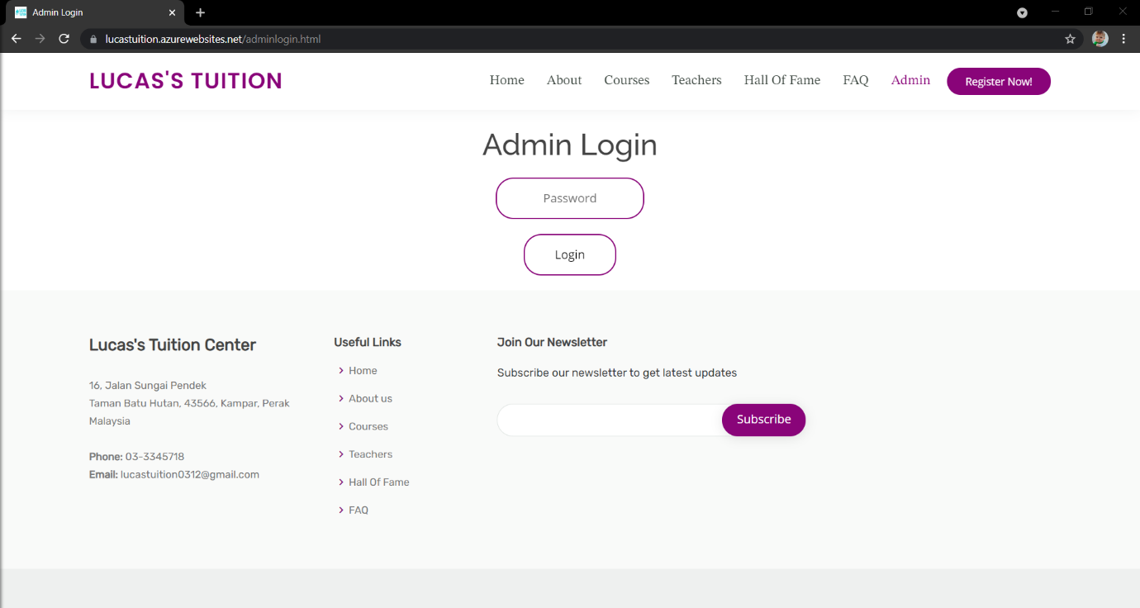

This page is for admin use only, it will ask admin to key in password and it will direct admin to other page.

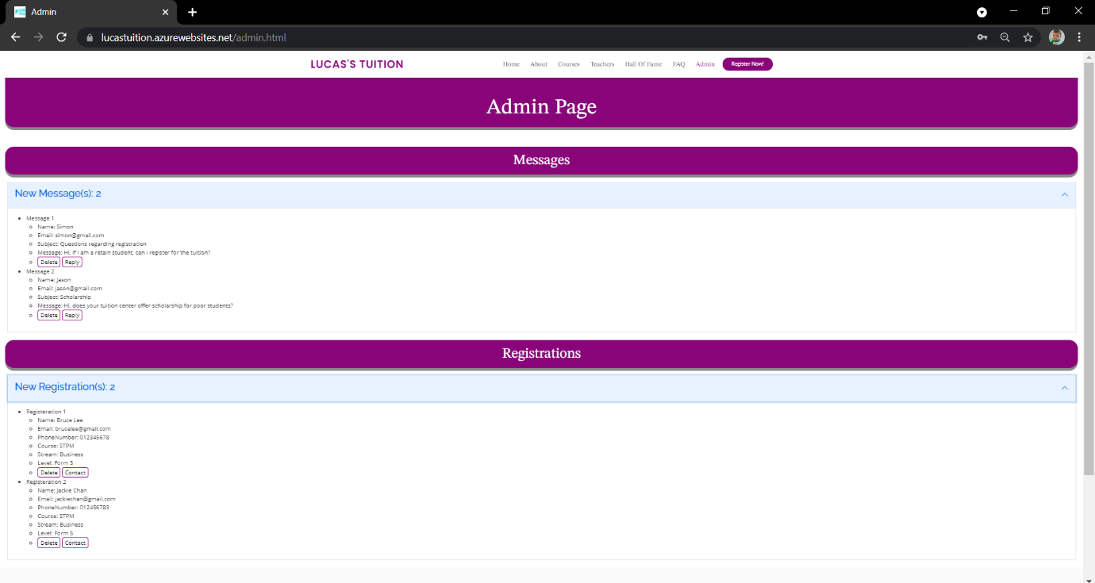

After admin log in, admin can read about the new messages and new registrations. Admin can also delete it or contact them.

**Register Now page**

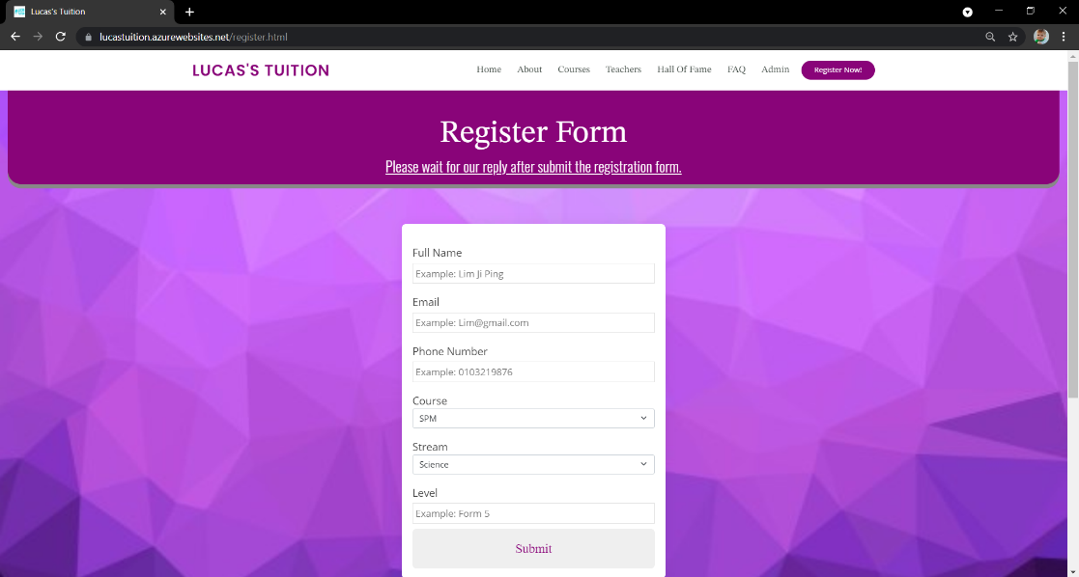

It allows user to register what the course they choose to study. It will send a notification to user after successful register.



**Footer**

The footer contains at all pages, it contains some information of tuition and some useful links. Also, it allows user to subscribe to our tuition.

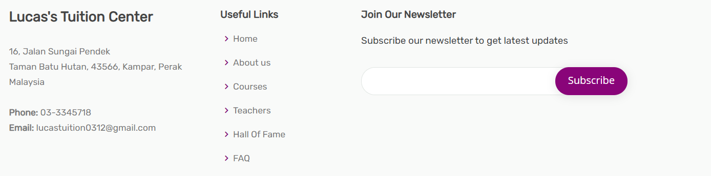

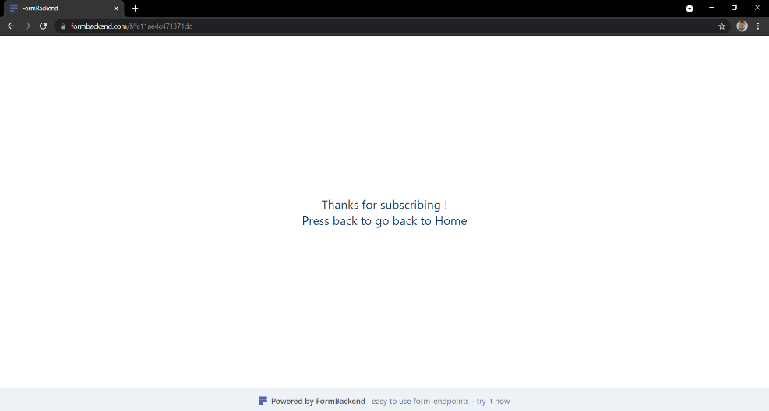

# References

(2021). Retrieved from Catalyst EDU: https://www.catalyst.edu.my/

(2021). Retrieved from VBest: https://www.vbest.edu.my

LEE, K. (2021). Retrieved from AI Tuition Centre: https://aituition.com